Problem Statement and Architecture

The Challenge of Modern Traffic Management
As our cities grow, traffic congestion is becoming a massive headache—logistically, economically, and environmentally. Traditionally, traffic management systems try to solve this by relying on rigid physical hardware, like embedded road sensors, radar, or traffic cameras. While these tools are great at capturing raw numbers like vehicle speed or density, they are incredibly expensive to set up and maintain. More importantly, they completely lack real-world context.
The biggest blind spot of these hardware systems is that they miss out on the incredible amount of live, highly contextual information that everyday citizens share. People are constantly tweeting about road conditions, calling emergency lines, or posting on community apps like Waze. When a human reads a tweet saying, "Torrential rain and bumper-to-bumper cars completely stalled on the highway," we instantly understand exactly what's happening. But for a traditional computer system, this messy, unstructured natural language is completely useless.

My Proposed Solution
For this project, I wanted to figure out how to bridge that gap. I built an "AI-Based Traffic Congestion Severity Analyzer" that takes messy, unstructured human reports and turns them into reliable, deterministic mathematical models. The core idea behind my project is simple: Artificial Intelligence is amazing at understanding language, but mathematical fuzzy logic is much safer and more reliable for actually controlling systems and calculating metrics.
I designed the architecture in three distinct stages:
- Natural Language Extraction (The LLM): First, a Large Language Model reads the messy user report. Its only job here is to extract two specific numbers—Traffic Volume and Weather Severity—and throw away all the extra conversational noise.
- Deterministic Inference (Fuzzy Logic): Next, a mathematical Fuzzy Inference System takes those extracted numbers. By running them through a set of overlapping rules, it calculates a highly reliable "Congestion Severity Score."
- Conversational Synthesis (The LLM): Finally, the system sends that mathematical score back to the LLM. The AI looks at the original report, the variables, and the final score, and writes a helpful, conversational advisory for the driver.
By combining these technologies, my application gets the best of both worlds: the flexible reasoning of generative AI and the rock-solid predictability of a traditional fuzzy logic controller.

The Role of the AI Component (LangChain)

The Reasoning Engine: Gemini 3.6 Flash
A lot of modern applications just use Large Language Models as simple chatbots. For this project, however, I am using Google's gemini-3.6-flash model as a programmatic reasoning engine. Its main job isn't just to talk; it's to structure unstructured data. To orchestrate this, I used LangChain, specifically leveraging its modern Expression Language (LCEL) to create a really clean, predictable processing pipeline.

The Data Extraction Chain
To process the citizen reports properly, I had to put some strict behavioral constraints on the AI. If a user types, "It is pouring rain and cars are barely moving," I don't want the system to reply with a conversational, "I'm sorry you're stuck in traffic!" I need hard integers to feed into my math engine.
To pull this off, I used LangChain's PromptTemplate. I engineered a very strict prompt that tells the AI: "Extract traffic volume (0-100 scale) and weather severity (0-10 scale)... Return ONLY a valid JSON object."
By chaining this to a StrOutputParser(), I essentially forced the LLM to strip away all its conversational filler and just hand me a clean JSON string (like {"volume": 85, "weather": 8}). This proves the LLM is actually doing real language reasoning—it has to understand context clues and weigh adjectives to figure out those numbers—rather than just parroting text. My Python backend then securely parses that JSON to get the integers.

The Conversational Advisory Chain
Once my fuzzy logic engine (which I'll explain next) calculates the final congestion score, it triggers a second LangChain sequence. I call this the explanatory chain, because data isn't very useful if normal people can't understand it.
This second chain takes in everything: the original unstructured text, the volume and weather integers the AI found earlier, and the final fuzzy severity score. I prompted the LLM to synthesize all these pieces and generate a conversational, context-aware explanation of the traffic jam. I also asked it to suggest a practical action for the driver, like "Take an alternate route" or "Turn on your hazard lights." This beautifully closes the loop—taking raw human input, turning it into math, and turning the result back into actionable human advice.

The Fuzzy Logic Component

Overcoming Binary Limitations
While the LangChain setup handles the messy language, the actual "brain" making decisions in this application is a genuine Fuzzy Inference System that I built in Python using the skfuzzy library.
Standard binary programming (like basic if-else statements) operates in absolutes. A road is either "congested" (1) or "not congested" (0). But real-world traffic doesn't work like that; it's a spectrum. Concepts like "heavy volume" or "bad weather" are highly subjective. Fuzzy logic solves this by modeling "degrees of truth," allowing a variable to partially belong to multiple categories at the same time, much like how human intuition works.

Defining Linguistic Variables and Membership Functions
To model the traffic properly, I defined three main variables using Triangular Membership Functions (trimf). I chose triangular functions because they are computationally efficient and map really well to how people perceive gradual changes in weather and traffic.
Input 1: Traffic Volume
I put the extracted traffic volume on a scale from 0 to 100, and split it into three overlapping fuzzy sets:
- Low: Peaks at 0, dropping off to 0 truth by 50.
- Medium: Starts at 20, peaks at 50, and drops off by 80.
- High: Starts at 50, and peaks all the way up to 100.
Because these triangles overlap, a volume input of 60 isn't just exclusively "medium" or exclusively "high." It holds partial membership in both sets, which reflects the real-world nuance of traffic density.
Input 2: Weather Severity
I put the extracted weather condition on a smaller scale from 0 to 10, mapping it into two sets:
- Clear: Peaks at 0 and drops off by 5.
- Bad: Starts at 3 and peaks up to 10.
Output: Congestion Severity
For the final output, I used a 0 to 100 scale to define three fuzzy sets: Low (0-40), Moderate (20-80), and Critical (60-100). By setting up these membership functions, the system was ready to evaluate complex rules.

Fuzzy Rules & Defuzzification

The Knowledge Base and Rule Evaluation
Once the inputs are fuzzified into "degrees of truth," the inference engine runs them against a set of specific rules. If I had just used standard if-else programming, a tiny drop in traffic volume (say, from 51 to 49) might cause the system to drastically jump from "High" to "Low" severity. That kind of jarring output isn't helpful in the real world.
Instead, my Fuzzy Inference System evaluates multiple rules simultaneously. I built the logic around these four core rules:
- Rule 1: IF volume is high AND weather is bad, THEN severity is critical.
- Rule 2: IF volume is high AND weather is clear, THEN severity is moderate.
- Rule 3: IF volume is medium, THEN severity is moderate.
- Rule 4: IF volume is low, THEN severity is low.
When evaluating rules with an "AND" condition (like Rules 1 and 2), the system uses the Mamdani inference method, which looks at the minimum truth value. For example, if the volume is heavily high (0.8 truth) but the weather is only slightly bad (0.4 truth), Rule 1 evaluates at 0.4. This prevents the system from blowing the severity out of proportion if one of the conditions isn't actually that bad.

Aggregation and Defuzzification
Every time a user submits a report, their input naturally triggers multiple overlapping rules. For instance, a volume of 65 will partially trigger Rule 2 and Rule 3 at the same time. The system takes the outputs from all these triggered rules and aggregates them, combining their shapes into one complex geometric area on my final 0-100 severity scale.
Finally, the system has to turn that fuzzy geometric shape back into a single, usable number. This is called Defuzzification. I used the Centroid method (Center of Gravity) for this. The math engine calculates the exact center of mass of that aggregated shape to give me a highly precise severity score. That crisp number is what I pass back to the Streamlit UI to update the charts, and to the LLM to write the final explanation.

Implementation and Links

Application Interface and Deployment
Since this needed to be a hosted mini-project, I wanted the interface to be accessible and visually engaging. Instead of a boring terminal script, I built a browser-based analytics dashboard using the Streamlit framework.
To make it look professional, I injected custom CSS to create gradient text and styled, floating metric cards that display the LangChain variables side-by-side with the Fuzzy score. I also integrated the plotly library to render a dynamic, color-coded gauge chart. This chart maps the final defuzzified score into green, yellow, or red zones, so a user can instantly understand how bad the traffic is before they even read the AI's advisory text.

Project Deliverables
(Below is a screenshot of the application successfully extracting variables from a natural language report, calculating the fuzzy logic score, and generating the final AI advisory).
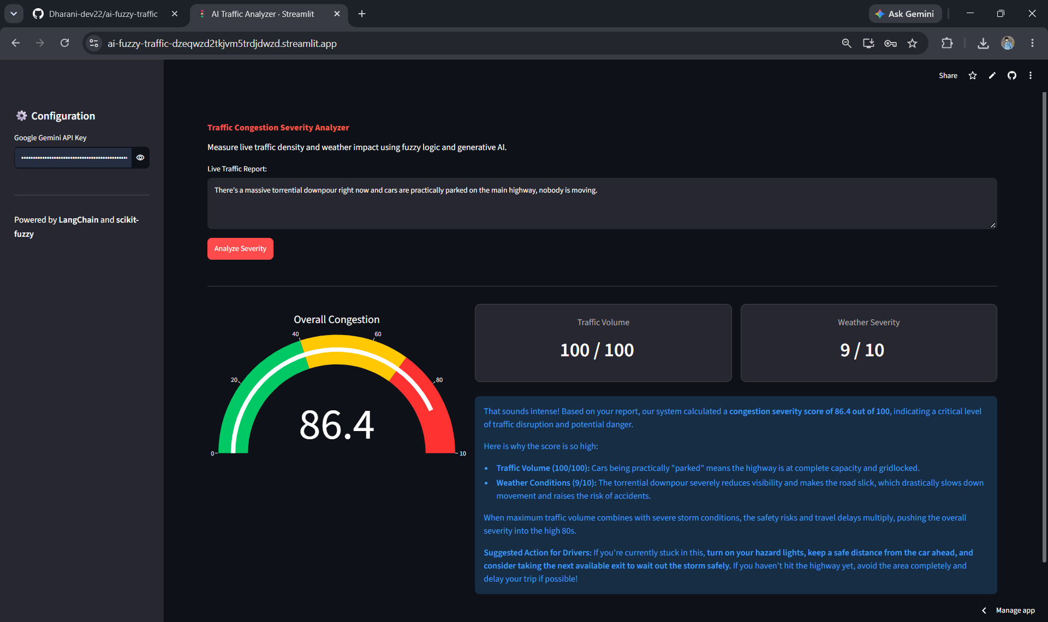

Repository and Live Application
All of the code for this project is open-source and version-controlled. I have successfully deployed it to Streamlit Community Cloud so that anyone can test this hybrid AI and Fuzzy Logic architecture directly in their browser.
- GitHub Repository: https://github.com/Dharani-dev22/ai-fuzzy-traffic
- Live Hosted Application: https://ai-fuzzy-traffic-dzeqwzd2tkjvm5trdjdwzd.streamlit.app/
Ultimately, this project proves that if you combine the incredible contextual reasoning of Large Language Models with the safe, mathematical predictability of Fuzzy Inference Systems, you can build a highly effective tool for solving real-world problems like traffic management.

